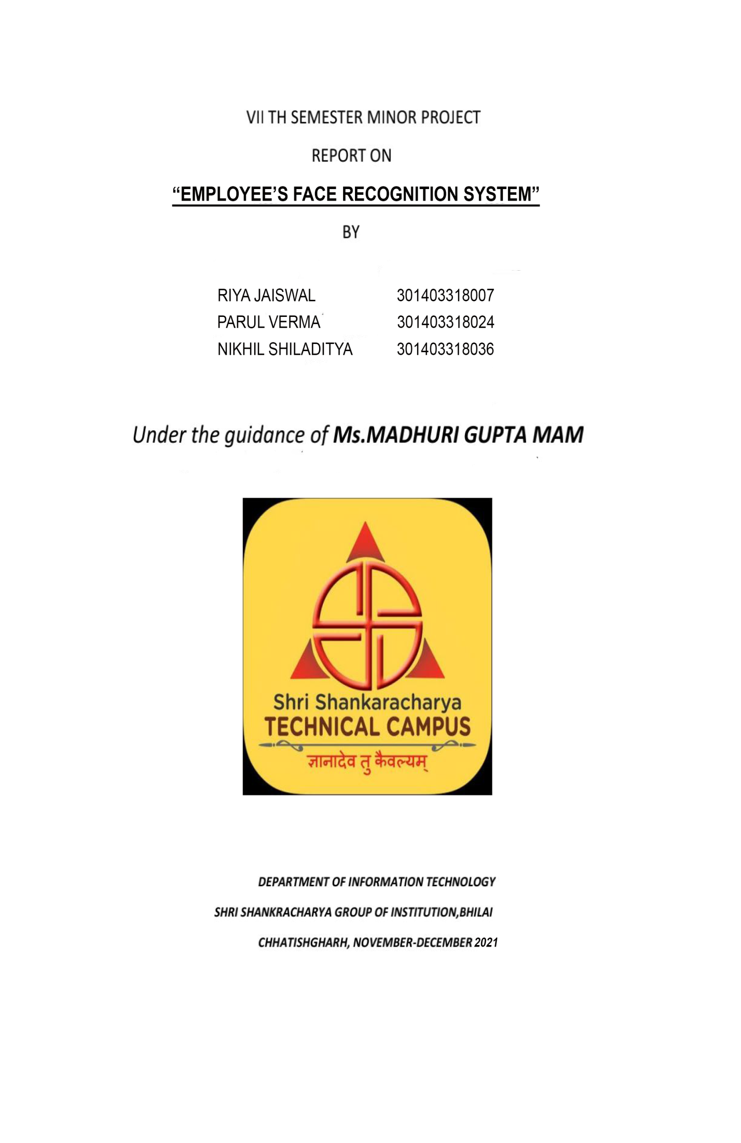

**INDEX**

**INTRODUCTION………………………………………………………………2**

**LITERATURE REVIEW ………………………………………………………4**

**PROJECT OVERVIEW………………………………………………………..6**

**SOFTWARE AND HARDWARE……………………………………………...7**

**HISTORY OF FACE RECOGNITION……………………………………….8**

* **PROBLEMS………………………………………….11**

**METHODOLOGIES……………………………………………………………12**

* **IMAGE PROCESSING……………………………...18**
* **FACE DETECTION…………………………….......21**
* **FACE RECOGNITION……………………………...22**
* **FACE RECOGNITION PROCESS………………..31**

**RESULTS………………………………………………………………………..36**

**CONCLUSIONS…………………………………………………………………41**

**FUTURE SCOPE………………………………………………………………..41**

**REFERNCES…………………………………………………………………….42**

**INTRODUCTION**

ABSTRACT

The smart environment is one that is able to identify the people, interpret their action, and react accordingly.

Thus the most appropriate concept for doing so is the Face recognition System and its the building blocks for the identification of the person. Face recognition devices are ideal for that type of smart environments, since they are fast, cheap, unobtrusive. Primarily humans are comfortable with this type of smart environment because they recognize each other by their faces so they will not face any difficulties for interacting with the same kinds of devices. The face recognition system when combines with the voice recognition will give more effective result.

Facial Recognition System are built in way that they will analyze the incoming image of a person standing in front of the device , match it with the database that they have which consist the database of all the employees and other databases and will the desired result on the basis of its analysis. Our project is primarily focused on the app based system in which we have made the UI design and the stored the database of the employees of the company. We also have a database for the visitors that means whenever a visitor will visit, the system will store the temporary data of the visitor and will enter in the building. We have also added the feature of recording the In-time and Out-time of the employees and the visitors entering in the building.

The project is based on Applied Artificial Intelligence Approach which aims to produce commercially viable “smart” systems or security system that is able to recognize the faces of people who permitted to enter the building. We have Sigma for the designing of the User Interface and it is also based upon Machine Learning.

INTRODUCTION

Compressing an image is significantly different than compressing raw binary data. Of course, general purpose compression programs can be used to compress images, but the result is less than optimal. This is because images have certain statistical properties which can be exploited by encoders specifically designed for them. Also, some of the finer details in the image can be sacrificed for the sake of saving a little more bandwidth or storage space. This also means that lossy compression techniques can be used in this area.

Image Processing is a technology which is nowadays most commonly used and which is found to be very evident for the users to use. Face recognition today is a big part of our lives like we have that system in our mobile phones and there are many places where this system is installed and coming in a huge use and gives a great advantage also.

**LITERATURE REVIEW**

A paragraph introducing the chapter. It includes how many sections and sub-section, chapter is divided a brief detail

Includes last 5-6 year Literature Survey.

Fernando C. Monteiro proposed a new image segmentation method comprises of edge and region based information with the help of spectral method and morphological algorithm of watershed. Firstly, they reduce the noise from image using bilateral filter as a pre-processing step, secondly, region merging is used to perform preliminary segmentation, region similarity is generated and then graph based region grouping is perform using Multi-class Normalized Cut method [1]. Berkley segmentation dataset is use as a dataset. They compare the technique with mean shift, multi-scale graph based segmentation, and JSEG. It is found that proposed technique has outperformed other methods and produce better results. R. V. Patil claims that if the number of clusters is estimated in accurate manner, K-means image segmentation will provide better results. They proposed a new method based on edge detection to estimate number of clusters. Phase congruency is used to detect the edges .Then these edges are used to find clusters. Threshold and Euclidean distance issued in order to make clusters. K-means is sued to find the final segmentation of image. MATLAB is used to implement the proposed technique. Experiments are performed on nine different images and results shows that number of clusters is accurate and optimal [2]. Weihong Cui Yi Zhang proposed an edge based auto threshold select method to generate multi-scale image segmentation. Band weight and NDVI (Normalized Difference Vegetation Index) is used to calculate edge weight. MST and Edge based Threshold method is used to perform image segmentation. Experiments are performs on multi-scale resolution images, i.e., Quick-bird multispectral images. Results have shown that their method maintain the object information and keep object boundaries while segment the image [3]. Anna Fabijańska introduced a new method uses Variance Filter for edge detection in image segmentation process. Their method found the edge position using Variance Filter. Sobel Gradient filter with K-means is also used to extract the edges and compared with the proposed technique. The effect of filtering window size on determining edges is also discussed and it is found that if the 9×9 window is used to extract edges then edge is complete accurately match the shape of object in the image [4]. Mohammed J. Islam found that Computer Vision is a best solution for real time inspection of capsules in pharmaceutical industry. Author has developed a system for quality inspection using edge based image segmentation techniques [5]. They used Sobel Edge Detector in order to detect edges with noise-suppression property. After edge detection, Otsu Thresholding technique is used for localization of background and foreground pixels. Experiments are conducted and results are compared with NN-based segmentation technique building Visual C++.Results outperform NN technique on the basis of accuracy and processing time difference of 10 ms [6].

**PROJECT OVERVIEW**



**SOFTWARE AND HARDWARE**

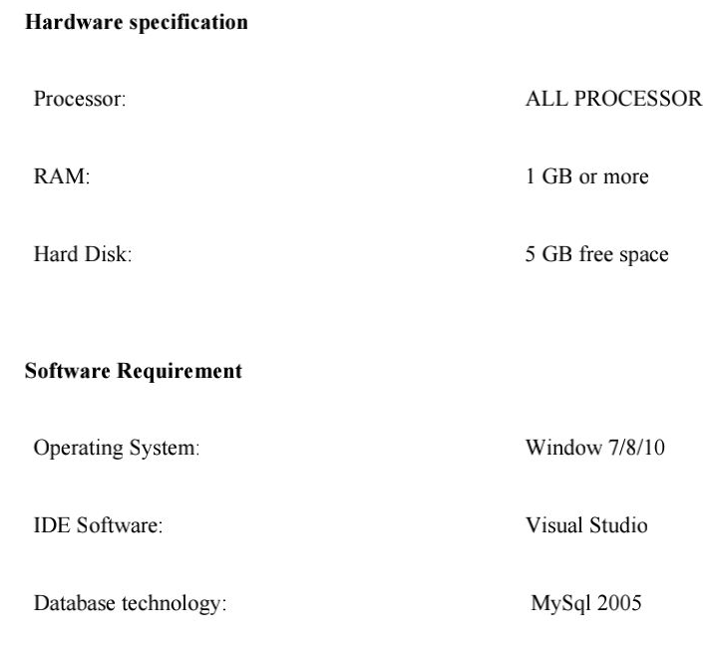

**HISTORY OF FACE RECOGNITION**







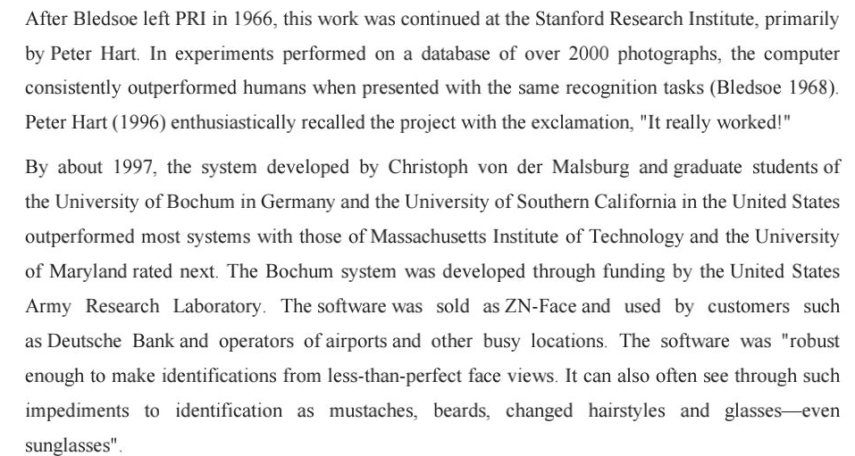



**PROBLEMS**



**METHODOLOGIES**















IMAGE PROCESSING

Image processing can be defined as the manipulation of an image for the purpose of either extracting information from the image or producing an alternative representation of the image.

Image compression reduce the size of image data file while retaining necessary information. The aim of image enhancement is to improve the interpretability or perception of information in images for human viewers, or to provide `better' input for other automated image processing techniques. Several techniques are there for Image compression and enhancement and de-noising. Image compression can be done by DCT is most efficient for compression. The DCT, and in particular the DCT-II, is often used in signal and image processing, especially for lossy data compression, because it has a strong "energy compaction" property, as most of the signal information tends to be concentrated in a few low-frequency components of the DCT. Wavelet Based Image De-noising contains all digital images contain some degree of noise. Image de-noising algorithm attempts to remove this noise from the image. Hard thresholding is a keep or kill rule whereas soft thresholding shrinks the coefficients above the threshold in absolute value. It is a shrink or kill rule. Histogram equalization is a common technique for enhancing the appearance of images. Histogram equalization involves finding a grey scale transformation function that creates an output image with a uniform histogram (or nearly so).

**1.2 Need of compression**

Image Compression addresses the problem of reducing the amount of data required to represent the digital image. Compression is achieved by the removal of one or more of three basic data redundancies: Coding redundancy, which is present when less than optimal (i.e. the smallest length) code words are used; Inter pixel redundancy, which results from correlations between the pixels of an image; &/or psycho visual redundancy which is due to data that is ignored by the human visual system (i.e. visually nonessential information).Huffman codes contain the smallest possible number of code symbols (e.g., bits) per source symbol (e.g., grey level value) subject to the constraint that the source symbols are coded one at a time. So, Huffman coding when combined with technique of reducing the image redundancies using Discrete Cosine Transform (DCT) helps in compressing the image data to a very good extent.

FACE DETECTION



FACE RECOGNITION







FISHERFACE































**RESULTS**





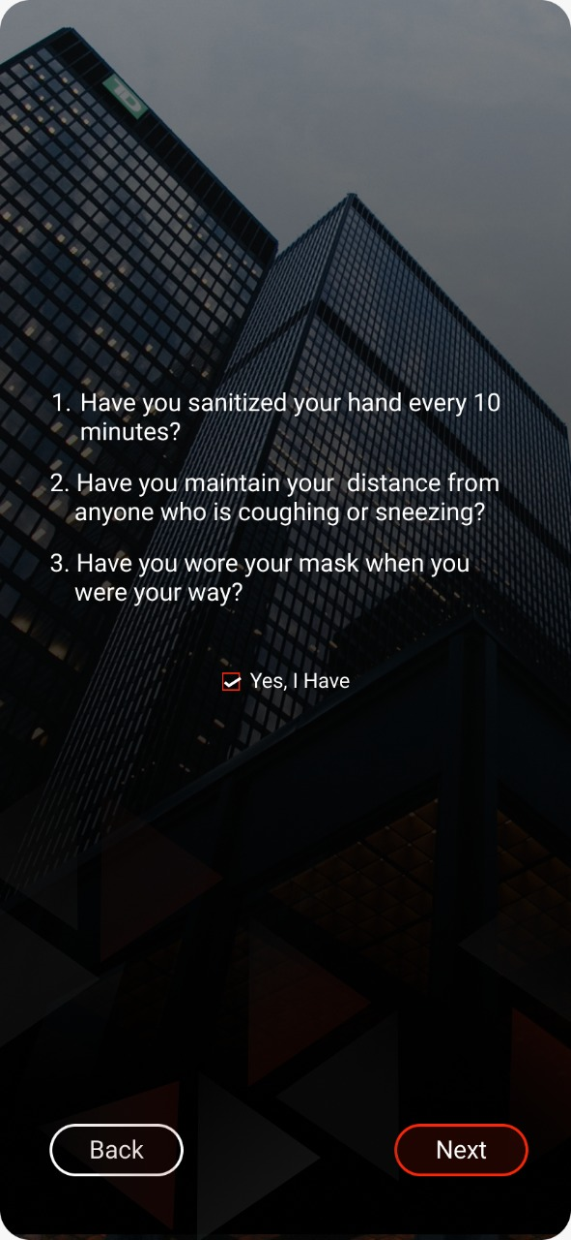

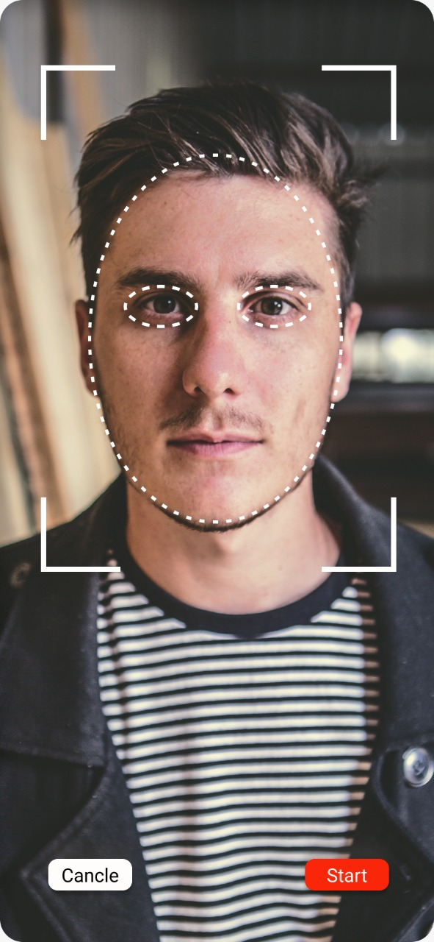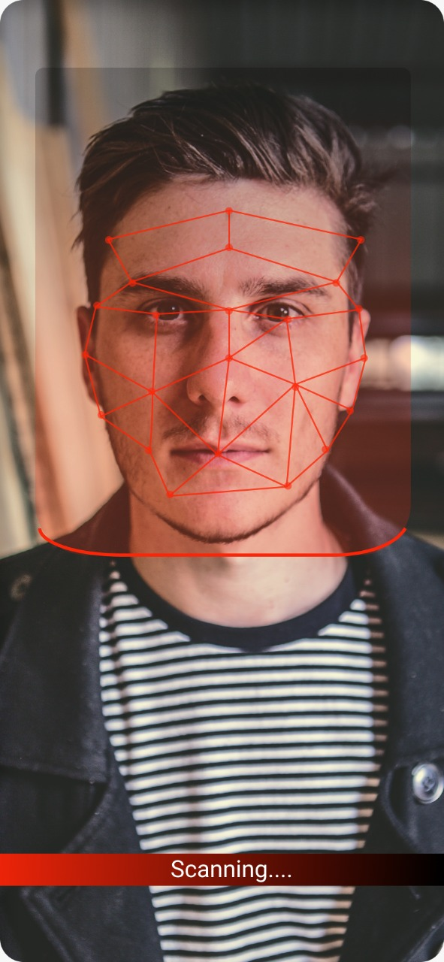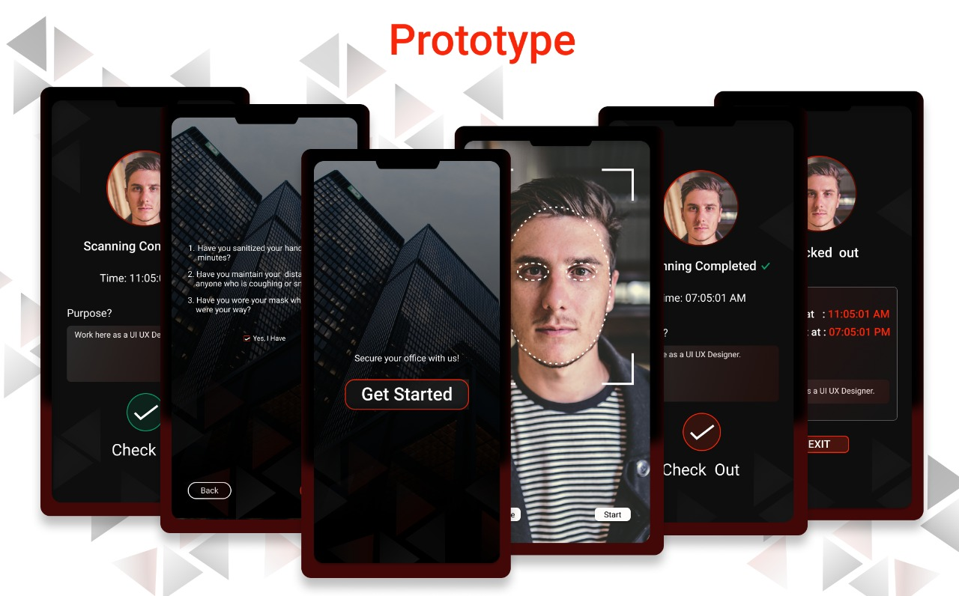



**CONCLUSION**



**FUTURE SCOPE**



**REFERENCES**

* Geeks for Geeks
* W3schools
* Java T Point
* Liang, L., Ai, H.: Summary on Face detection Researches